 | 
Data Flow Diagram
Date | 15 March 2026 26 June 2026
Team ID | xxxxxx EduGenie - Google Gemini Powered Learning Assistant
Project Name | xxxxxx EduGenie - Google Gemini Powered Learning Assistant
Maximum Marks | 2 Marks
Data Flow Diagram
Create a Data Flow Diagram (DFD) to show how data moves through your system - between external entities, processes, and data stores. Use the symbol legend below as a guide.
DFD Symbol Legend
Symbol | Name | Description
Oval / Rounded shape | External Entity | A person, organization, or system outside the project that sends or receives data (e.g.,  Customer, Payment Gateway).
Rectangle with  numbered header | Process | An activity that transforms incoming data into outgoing data (e.g., Validate Request, Process Order).
Rectangle (solid fill, no number) | Data Store | A place where data is held for later use (e.g., Customer Database, Inventory).
Labeled arrow | Data Flow | The movement of data between entities,  processes, and data stores, labeled with what data is being passed.
Example
The diagram below illustrates how the symbols above come together to form a complete data flow diagram.

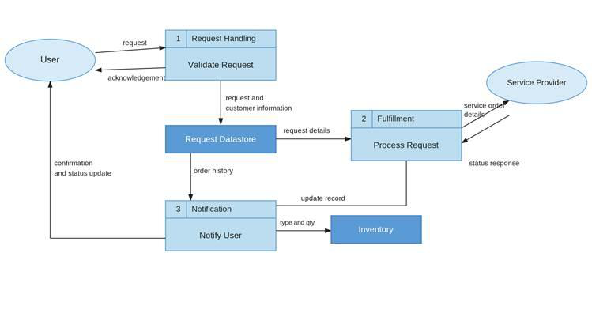
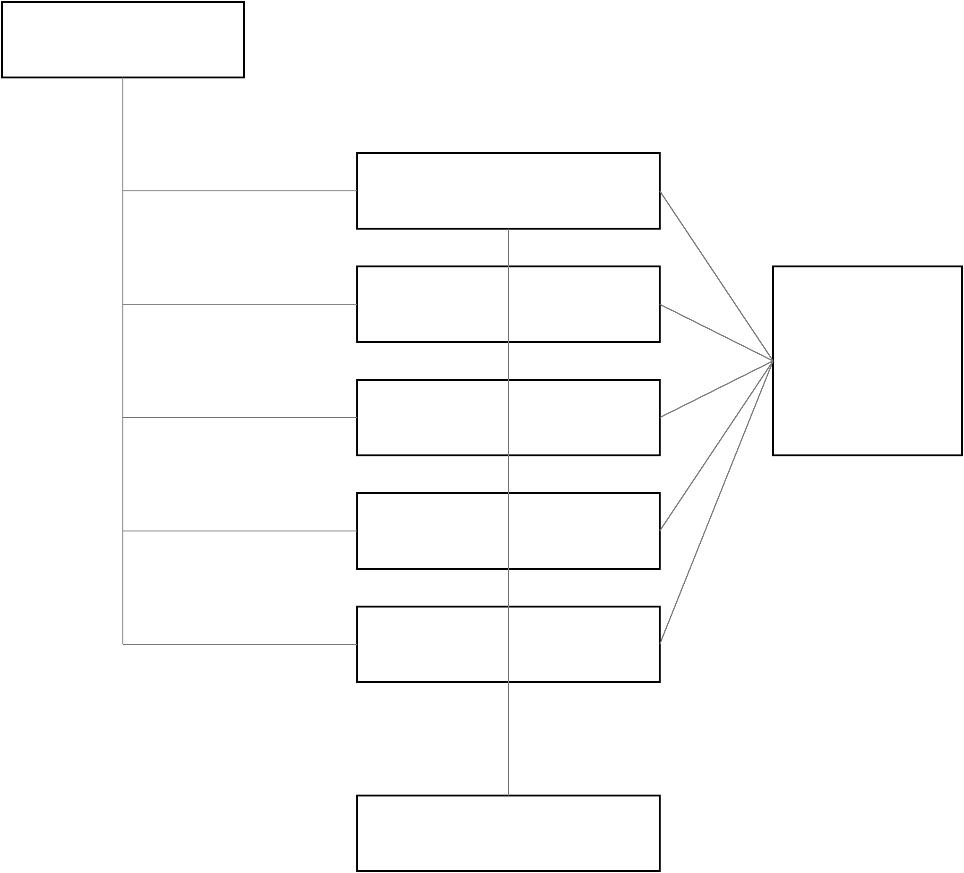
  EduGenie System Data Flow Diagram (Level 1 DFD) | 
User (Student)
1.0 Ask Question
2.0 Explain Concept | External AI Services  (Gemini API / Local T5) (Gemini API / Local T5)
3.0 Generate Quiz
4.0 Summarize Text
5.0 Recommend Path
D1: JSON Data Store logs

